***University Physics Volume I***

**Unit 1: Mechanics**

**Chapter 5: Newton’s Laws of Motion**

**Conceptual Questions**

1. What properties do forces have that allow us to classify them as vectors?

Solution

Forces are directional and have magnitude.

1. Taking a frame attached to Earth as inertial, which of the following objects cannot have inertial frames attached to them, and which are inertial reference frames?
2. A car moving at constant velocity
3. A car that is accelerating
4. An elevator in free fall
5. A space capsule orbiting Earth
6. An elevator descending uniformly

Solution

Because (b), (c), and (d) all involve accelerating reference frames, they are noninertial reference frames; (a) and (e) involve constant velocity, so they are inertial reference frames.

1. A woman was transporting an open box of cupcakes to a school party. The car in front of her stopped suddenly; she applied her brakes immediately. She was wearing her seat belt and suffered no physical harm (just a great deal of embarrassment), but the cupcakes flew into the dashboard and became “smushcakes.” Explain what happened.

Solution

The cupcake velocity before the braking action was the same as that of the car. Therefore, the cupcakes were unrestricted bodies in motion, and when the car suddenly stopped, the cupcakes kept moving forward according to Newton’s first law.

1. Why can we neglect forces such as those holding a body together when we apply Newton’s second law?

Solution

Internal forces on the constituent components of a system cancel each other out to produce a net force of zero and hence do not contribute to the motion of the system.

1. A rock is thrown straight up. At the top of the trajectory, the velocity is momentarily zero. Does this imply that the force acting on the object is zero? Explain your answer.

Solution

No. If the force were zero at this point, then there would be nothing to change the object’s momentary zero velocity. Since we do not observe the object hanging motionless in the air, the force could not be zero.

1. What is the relationship between weight and mass? Which is an intrinsic, unchanging property of a body?

Solution

Classically, mass is a constant and intrinsic property of matter, whereas weight is the manifestation of gravity acting on a mass.

1. How much does a 70-kg astronaut weight in space, far from any celestial body? What is her mass at this location?

Solution

The astronaut is truly weightless in the location described, because there is no large body (planet or star) nearby to exert a gravitational force. Her mass is 70 kg regardless of where she is located.

1. Which of the following statements is accurate?
2. Mass and weight are the same thing expressed in different units.
3. If an object has no weight, it must have no mass.
4. If the weight of an object varies, so must the mass.
5. Mass and inertia are different concepts.
6. Weight is always proportional to mass.

Solution

e

1. When you stand on Earth, your feet push against it with a force equal to your weight. Why doesn’t Earth accelerate away from you?

Solution

The force you exert (a contact force equal in magnitude to your weight) is small. Earth is extremely massive by comparison. Thus, the acceleration of Earth would be incredibly small. To see this, use Newton’s second law to calculate the acceleration you would cause if your weight is 600.0 N and the mass of Earth is .

1. How would you give the value of  in vector form?

Solution

Since  always acts vertically downward, we write it this way: .

1. Identify the action and reaction forces in the following situations: (a) Earth attracts the Moon, (b) a boy kicks a football, (c) a rocket accelerates upward, (d) a car accelerates forward, (e) a high jumper leaps, and (f) a bullet is shot from a gun.

Solution

a. action: Earth pulls on the Moon, reaction: Moon pulls on Earth; b. action: foot applies force to ball, reaction: ball applies force to foot; c. action: rocket pushes on gas, reaction: gas pushes back on rocket; d. action: car tires push backward on road, reaction: road pushes forward on tires; e. action: jumper pushes down on ground, reaction: ground pushes up on jumper; f. action: gun pushes forward on bullet, reaction: bullet pushes backward on gun.

1. Suppose that you are holding a cup of coffee in your hand. Identify all forces on the cup and the reaction to each force.

Solution

force of hand on cup, reaction: force of cup on hand; force of Earth on cup (that is, weight), reaction: force of cup on Earth

1. (a) Why does an ordinary rifle recoil (kick backward) when fired? (b) The barrel of a recoilless rifle is open at both ends. Describe how Newton’s third law applies when one is fired. (c) Can you safely stand close behind one when it is fired?

Solution

a. The rifle (the shell supported by the rifle) exerts a force to expel the bullet; the reaction to this force is the force that the bullet exerts on the rifle (shell) in opposite direction. b. In a recoilless rifle, the shell is not secured in the rifle; hence, as the bullet is pushed to move forward, the shell is pushed to eject from the opposite end of the barrel. c. It is not safe to stand behind a recoilless rifle.

1. A table is placed on a rug. Then a book is placed on the table. What does the floor exert a normal force on?

Solution

only the rug

1. A particle is moving to the right. (a) Can the force on it to be acting to the left? If yes, what would happen? (b) Can that force be acting downward? If yes, why?

Solution

a. Yes, the force can be acting to the left; the particle would experience acceleration opposite to the motion and lose speed. B. Yes, the force can be acting downward because its weight acts downward even as it moves to the right.

1. In completing the solution for a problem involving forces, what do we do after constructing the free-body diagram? That is, what do we apply?

Solution

We apply Newton’s first law if the forces are balanced or Newton’s second law if the system is accelerating.

1. If a book is located on a table, how many forces should be shown in a free-body diagram of the book? Describe them.

Solution

two forces of different types: weight acting downward and normal force acting upward

1. If the book in the previous question is in free fall, how many forces should be shown in a free-body diagram of the book? Describe them.

Solution

only one force: weight acting downward

**Problems**

1. Two ropes are attached to a tree, and forces of  and  are applied. The forces are coplanar (in the same plane). (a) What is the resultant (net force) of these two force vectors? (b) Find the magnitude and direction of this net force.

Solution

a. ; b. the magnitude is , and the direction is 

1. A telephone pole has three cables pulling as shown from above, with , , and . (a) Find the net force on the telephone pole in component form. (b) Find the magnitude and direction of this net force.

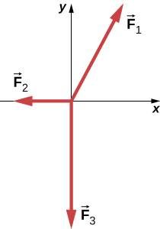

Solution

a. ; b.  and  from the positive *x*-axis

1. Two teenagers are pulling on ropes attached to a tree. The angle between the ropes is . David pulls with a force of 400.0 N and Stephanie pulls with a force of 300.0 N. (a) Find the component form of the net force. (b) Find the magnitude of the resultant (net) force on the tree and the angle it makes with David’s rope.

Solution

a. ; b.  at  from David’s rope

1. Two forces of  and  act on an object. Find the third force  that is needed to balance the first two forces.

Solution



1. While sliding a couch across a floor, Andrea and Jennifer exert forces  and  on the couch. Andrea’s force is due north with a magnitude of 130.0 N and Jennifer’s force is  east of north with a magnitude of 180.0 N. (a) Find the net force in component form. (b) Find the magnitude and direction of the net force. (c) If Andrea and Jennifer’s housemates, David and Stephanie, disagree with the move and want to prevent its relocation, with what combined force  should they push so that the couch does not move?

Solution

a. ;

b. 299 N at  north of east;

c. 

1. Andrea, a 63.0-kg sprinter, starts a race with an acceleration of . What is the net external force on her?

Solution



1. If the sprinter from the previous problem accelerates at that rate for 20.00 m and then maintains that velocity for the remainder of a 100.00-m dash, what will her time be for the race?

Solution

Running from rest, the sprinter attains a velocity of



or , at end of acceleration. We find the time for acceleration using , or . For maintained velocity, , or . .

1. A cleaner pushes a 4.50-kg laundry cart in such a way that the net external force on it is 60.0 N. Calculate the magnitude of his cart’s acceleration.

Solution

 of the cart

1. Astronauts in orbit are apparently weightless. This means that a clever method of measuring the mass of astronauts is needed to monitor their mass gains or losses, and adjust their diet. One way to do this is to exert a known force on an astronaut and measure the acceleration produced. Suppose a net external force of 50.0 N is exerted, and an astronaut’s acceleration is measured to be . (a) Calculate her mass. (b) By exerting a force on the astronaut, the vehicle in which she orbits experiences an equal and opposite force. Use this knowledge to find an equation for the acceleration of the system (astronaut and spaceship) that would be measured by a nearby observer. (c) Discuss how this would affect the measurement of the astronaut’s acceleration. Propose a method by which recoil of the vehicle is avoided.

Solution

a. ; b. ;

c. If the force could be exerted on the astronaut by another source (other than the spaceship), then the spaceship would not experience a recoil.

1. In the following figure, the net external force on the 24-kg mower is given as 51 N. If the force of friction opposing the motion is 24 N, what force *F* (in newtons) is the person exerting on the mower? Suppose the mower is moving at 1.5 m/s when the force *F* is removed. How far will the mower go before stopping?

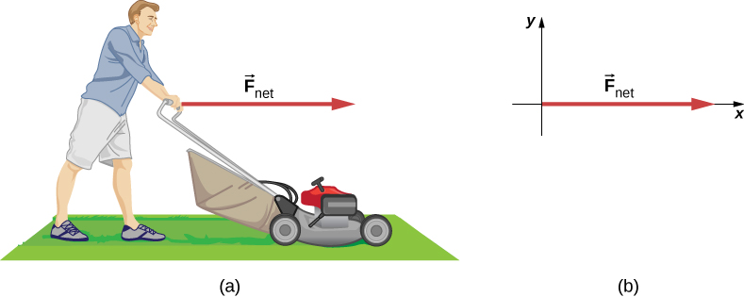

Solution



1. The rocket sled shown below accelerates opposite to the motion at a rate of . What force is necessary to produce this acceleration opposite to the motion? Assume that the rockets are off. The mass of the system is  kg.

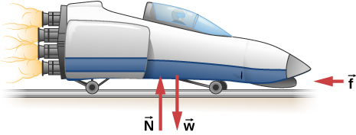

Solution



1. If the rocket sled shown in the previous problem starts with only one rocket burning, what is the magnitude of this acceleration? Assume that the mass of the system is  kg, the thrust *T* is  and the force of friction opposing the motion is 650.0 N. (b) Why is the acceleration not one-fourth of what it is with all rockets burning?

Solution

a. With only one rocket burning, , or 

b. The acceleration is not one-fourth of what it was with all rockets burning, because the friction is still as large as it was with all rockets burning.

1. What is the acceleration opposite to the motion of the rocket sled if it comes to rest in 1.10 s from a speed of 1000.0 km/h? (Such acceleration opposite to the motion caused one test subject to black out and have temporary blindness.)

Solution



1. Suppose two children push horizontally, but in exactly opposite directions, on a third child in a wagon. The first child exerts a force of 75.0 N, the second exerts a force of 90.0 N, friction is 12.0 N, and the mass of the third child plus wagon is 23.0 kg. (a) What is the system of interest if the acceleration of the child in the wagon is to be calculated? (See the free-body diagram.) (b) Calculate the acceleration. (c) What would the acceleration be if friction were 15.0 N?

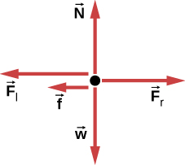

Solution

a. The system is the child in the wagon plus the wagon.

b. ,

so ;

c. 

1. A powerful motorcycle can produce an acceleration of  while traveling at 90.0 km/h. At that speed, the forces resisting motion, including friction and air resistance, total 400.0 N. (Air resistance is analogous to air friction. It always opposes the motion of an object.) What is the magnitude of the force that motorcycle exerts backward on the ground to produce its acceleration if the mass of the motorcycle with rider is 245 kg?

Solution



1. A car with a mass of 1000.0 kg accelerates from 0 to 90.0 km/h in 10.0 s. (a) What is its acceleration? (b) What is the net force on the car?

Solution

a. ;

b. 

1. The driver in the previous problem applies the brakes when the car is moving at 90.0 km/h, and the car comes to rest after traveling 40.0 m. What is the net force on the car during its acceleration opposite to the motion?

Solution



1. An 80.0-kg passenger in an SUV traveling at  km/h is wearing a seat belt. The driver slams on the brakes and the SUV stops in 45.0 m. Find the force of the seat belt on the passenger.

Solution



1. A particle of mass 2.0 kg is acted on by a single force  (a) What is the particle’s acceleration? (b) If the particle starts at rest, how far does it travel in the first 5.0 s?

Solution

a. ; b. The acceleration has magnitude , so .

1. Suppose that the particle of the previous problem also experiences forces  and  What is its acceleration in this case?

Solution



1. Find the acceleration of the body of mass 5.0 kg shown below.

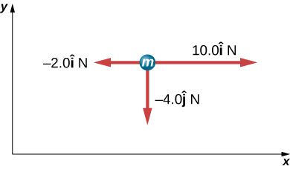

Solution



1. In the following figure, the horizontal surface on which this block slides is frictionless. If the two forces acting on it each have magnitude and , what is the magnitude of the resulting acceleration of the block?

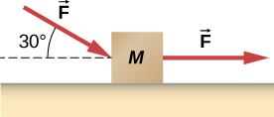

Solution



1. The weight of an astronaut plus his space suit on the Moon is only 250 N. (a) How much does the suited astronaut weigh on Earth? (b) What is the mass on the Moon? On Earth?

Solution

a.;

b. Mass does not change, so the suited astronaut’s mass on both Earth and the Moon is 150 kg.

1. Suppose the mass of a fully loaded module in which astronauts take off from the Moon is  kg. The thrust of its engines is  N. (a) Calculate the module’s magnitude of acceleration in a vertical takeoff from the Moon. (b) Could it lift off from Earth? If not, why not? If it could, calculate the magnitude of its acceleration

Solution



b. The module cannot take off from Earth.  of the spaceship on Earth, and .

1. A rocket sled accelerates at a rate of . Its passenger has a mass of 75.0 kg. (a) Calculate the horizontal component of the force the seat exerts against his body. Compare this with his weight using a ratio. (b) Calculate the direction and magnitude of the total force the seat exerts against his body.

Solution

a. ;

b. 

1. Repeat the previous problem for a situation in which the rocket sled accelerates opposite to the motion at a rate of . In this problem, the forces are exerted by the seat and the seat belt.

Solution

a. ;

b. 

1. A body of mass 2.00 kg is pushed straight upward by a 25.0 N vertical force. What is its acceleration?

Solution



1. A car weighing 12,500 N starts from rest and accelerates to 83.0 km/h in 5.00 s. The friction force is 1350 N. Find the applied force produced by the engine.

Solution



1. A body with a mass of 10.0 kg is assumed to be in Earth’s gravitational field with . What is the net force on the body if there are no other external forces acting on the object?

Solution

98 N

1. A fireman has mass *m*; he hears the fire alarm and slides down the pole with acceleration *a* (which is less than *g* in magnitude). (a) Write an equation giving the vertical force he must apply to the pole. (b) If his mass is 90.0 kg and he accelerates at  what is the magnitude of his applied force?

Solution

a. ; b. 

1. A baseball catcher is performing a stunt for a television commercial. He will catch a baseball (mass 145 g) dropped from a height of 60.0 m above his mitt. His mitt stops the ball in 0.0100 s. What is the force exerted by his mitt on the ball?

Solution

499 N

1. When the Moon is directly overhead at sunset, the force by Earth on the Moon, , is essentially at  to the force by the Sun on the Moon, , as shown below. Given that  and  all other forces on the Moon are negligible, and the mass of the Moon is  determine the magnitude of the Moon’s acceleration.

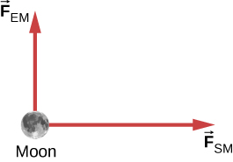

Solution



1. (a) What net external force is exerted on a 1100.0-kg artillery shell fired from a battleship if the shell is accelerated at  (b) What is the magnitude of the force exerted on the ship by the artillery shell, and why?

Solution

a.  b. The force exerted on the ship is also  because it is opposite the shell’s direction of motion.

1. A brave but inadequate rugby player is being pushed backward by an opposing player who is exerting a force of 800.0 N on him. The mass of the losing player plus equipment is 90.0 kg, and he is accelerating backward at . (a) What is the force of friction between the losing player’s feet and the grass? (b) What force does the winning player exert on the ground to move forward if his mass plus equipment is 110.0 kg?

Solution

a. 

b. 

1. A history book is lying on top of a physics book on a desk, as shown below; a free-body diagram is also shown. The history and physics books weigh 14 N and 18 N, respectively. Identify each force on each book with a double subscript notation (for instance, the contact force of the history book pressing against physics book can be described as ), and determine the value of each of these forces, explaining the process used.

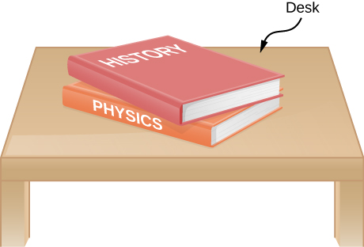

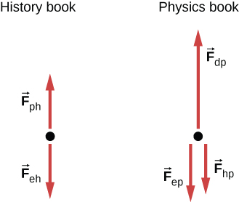

Solution

Because the weight of the history book is the force exerted by Earth on the history book, we represent it as  Aside from this, the history book interacts only with the physics book. Because the acceleration of the history book is zero, the net force on it is zero by Newton’s second law:  where  is the force exerted by the physics book on the history book. Thus,  We find that the physics book exerts an upward force of magnitude 14 N on the history book. The physics book has three forces exerted on it:  due to Earth,  due to the history book, and  due to the desktop. Since the physics book weighs 18 N,  From Newton’s third law,  so  Newton’s second law applied to the physics book gives  or  so  The desk exerts an upward force of 32 N on the physics book. To arrive at this solution, we apply Newton’s second law twice and Newton’s third law once.

1. A truck collides with a car, and during the collision, the net force on each vehicle is essentially the force exerted by the other. Suppose the mass of the car is 550 kg, the mass of the truck is 2200 kg, and the magnitude of the truck’s acceleration is . Find the magnitude of the car’s acceleration.

Solution



1. A leg is suspended in a traction system, as shown below. (a) Which pulley in the figure is used to calculate the force exerted on the foot? (b) What is the tension in the rope? Here  is the tension,  is the weight of the leg, and  is the weight of the load that provides the tension. Express answers in terms of the unknown masses and angle.

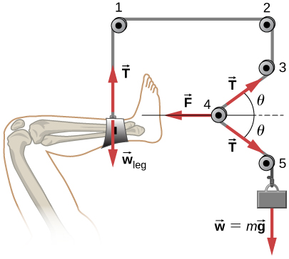

Solution

a. The free-body diagram of pulley 4:

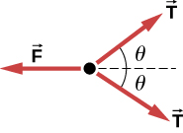

b. 

1. Suppose the shinbone in the preceding image was a femur in a traction setup for a broken bone, with pulleys and rope available. How might we be able to increase the force along the femur using the same weight?

Solution

Changing the angle  changes the magnitude of the exerted force. To increase the force, the angle  must be decreased.

1. A team of nine members each engage in a tug-of-war, pulling in opposite directions on a horizontal rope. Each of the first team’s members has an average mass of 68 kg and exerts an average force of 1350 N horizontally on the ground as they pull on the rope. Each of the second team’s members has an average mass of 73 kg and exerts an average force of 1365 N horizontally on the ground as they pull on the rope in the opposite direction. (a) What is magnitude of the acceleration of the two teams, and which team wins? (b) What is the tension in the section of rope between the teams?

Solution

a. 0.106 m/s2 in the direction of the second team. The second team wins the tug-of-war.

b. 65 N

1. What force does a trampoline have to apply to Jennifer, a 45.0-kg gymnast, to accelerate her straight up at ? The answer is independent of the velocity of the gymnast—she can be moving up or down or can be instantly stationary.

Solution



1. (a) Calculate the tension in a vertical strand of spider web if a spider of mass  hangs motionless on it. (b) Calculate the tension in a horizontal strand of spider web if the same spider sits motionless in the middle of it much like the tightrope walker in the following figure. The strand sags at an angle of  below the horizontal. Compare this with the tension in the vertical strand (find their ratio).

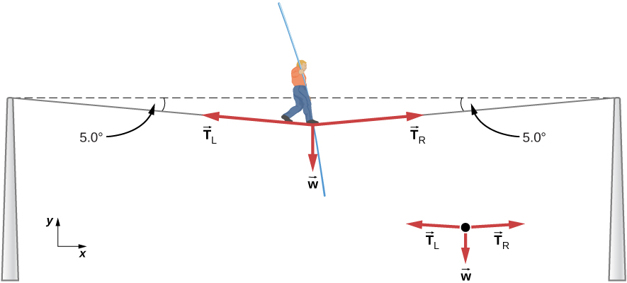

Solution

a. 

b. 

1. Suppose Kevin, a 60.0-kg gymnast, climbs a rope. (a) What is the tension in the rope if he climbs at a constant speed? (b) What is the tension in the rope if he accelerates upward at a rate of ?

Solution

a. ;

b. 

1. Show that, as explained in the text, a force  exerted on a flexible medium at its center and perpendicular to its length (such as on the tightrope wire in the following figure) gives rise to a tension of magnitude .



Solution

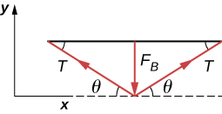



1. Consider the following image. The driver attempts to get the car out of the mud by exerting a perpendicular force of 610.0 N, and the distance she pushes in the middle of the rope is 1.00 m while she stands 6.00 m away from the car on the left and 6.00 m away from the tree on the right. What is the tension *T* in the rope, and how do you find the answer?

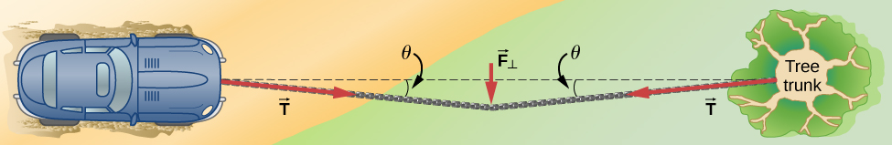

Solution

First, find the value of  using the right triangle formed from the distances given; we find that  Then, use this in the equation  to obtain the answer 1860 N.

1. A bird has a mass of 26 g and perches in the middle of a stretched telephone line. (a) Show that the tension in the line can be calculated using the equation . Determine the tension when (b)  and (c) . Assume that each half of the line is straight.

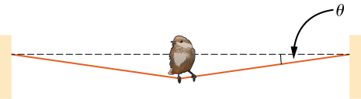

Solution

a. see Example: “What is the Tension in a Tightrope?”; b. 1.5 N; c. 15 N

1. One end of a 30-m rope is tied to a tree; the other end is tied to a car stuck in the mud. The motorist pulls sideways on the midpoint of the rope, displacing it a distance of 2 m. If he exerts a force of 80 N under these conditions, determine the force exerted on the car.

Solution

300 N

1. Consider the baby being weighed in the following figure. (a) What is the mass of the infant and basket if a scale reading of 55 N is observed? (b) What is tension  in the cord attaching the baby to the scale? (c) What is tension  in the cord attaching the scale to the ceiling, if the scale has a mass of 0.500 kg? (d) Sketch the situation, indicating the system of interest used to solve each part. The masses of the cords are negligible.

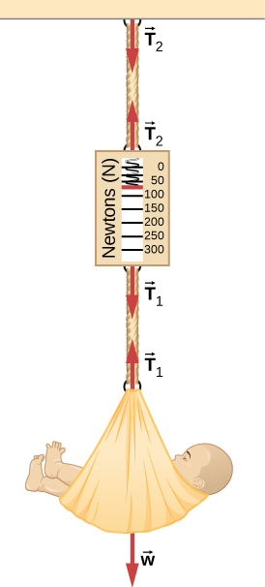

Solution

a. ; b. 55 N; c. ; d.

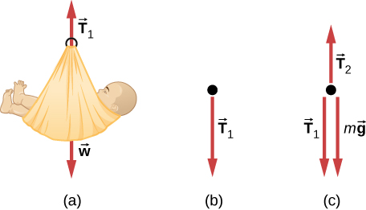

1. What force must be applied to a 100.0-kg crate on a frictionless plane inclined at  to cause an acceleration of  up the plane?

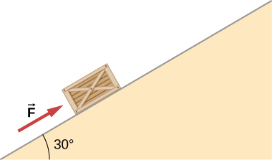

Solution

The net force parallel to the inclined plane to accelerate the crate must point up the plane with a magnitude satisfying Newton’s second law, that is, . Solving for *F* yields .

1. A 2.0-kg block is on a perfectly smooth ramp that makes an angle of  with the horizontal. (a) What is the block’s acceleration down the ramp and the force of the ramp on the block? (b) What force applied upward along and parallel to the ramp would allow the block to move with constant velocity?

Solution

a. , 17 N; b. 9.8 N

1. A ball of mass *m* hangs at rest, suspended by a string. (a) Sketch all forces. (b) Draw the free-body diagram for the ball.

Solution

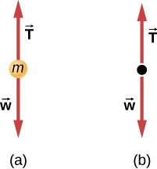

1. A car moves along a horizontal road. Draw a free-body diagram; be sure to include the friction of the road that opposes the forward motion of the car.

Solution

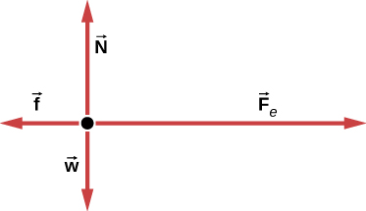

1. A runner pushes against the track, as shown. (a) Provide a free-body diagram showing all the forces on the runner. (*Hint:* Place all forces at the center of his body, and include his weight.) (b) Give a revised diagram showing the *xy*-component form.

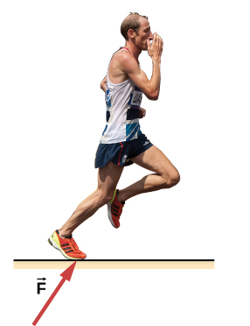

Solution

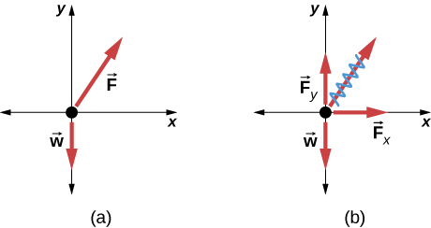

1. The traffic light hangs from the cables as shown. Draw a free-body diagram on a coordinate plane for this situation.

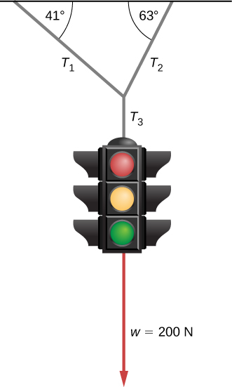

Solution

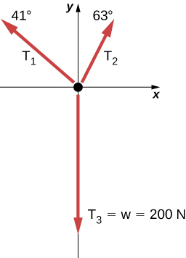

**Additional Problems**

1. Two small forces,  N and  N, are exerted on a rogue asteroid by a pair of space tractors. (a) Find the net force. (b) What are the magnitude and direction of the net force? (c) If the mass of the asteroid is 125 kg, what acceleration does it experience (in vector form)? (d) What are the magnitude and direction of the acceleration?

Solution

a. ; b. 16.9 N at  from the positive *x*-direction; c.  d.  at  from the positive *x*-direction

1. Two forces of 25 and 45 N act on an object. Their directions differ by . The resulting acceleration has magnitude of  What is the mass of the body?

Solution

5.90 kg

1. A force of 1600 N acts parallel to a ramp to push a 300-kg piano into a moving van. The ramp is inclined at . (a) What is the acceleration of the piano up the ramp? (b) What is the velocity of the piano when it reaches the top if the ramp is 4.0 m long and the piano starts from rest?

Solution

a.  b. 4 m/s

1. Draw a free-body diagram of a diver who has entered the water, moved downward, and is acted on by an upward force due to the water which balances the weight (that is, the diver is suspended).

Solution

Description: CNX_UPhysics_05_07_Diver_img

1. For a swimmer who has just jumped off a diving board, assume air resistance is negligible. The swimmer has a mass of 80.0 kg and jumps off a board 10.0 m above the water. Three seconds after entering the water, her downward motion is stopped. What average upward force did the water exert on her?

Solution

1157 N

1. (a) Find an equation to determine the magnitude of the net force required to stop a car of mass *m*, given that the initial speed of the car is  and the stopping distance is *x*. (b) Find the magnitude of the net force if the mass of the car is 1050 kg, the initial speed is 40.0 km/h, and the stopping distance is 25.0 m.

Solution

a. ; b. 2590 N

1. A sailboat has a mass of  kg and is acted on by a force of  N toward the east, while the wind acts behind the sails with a force of  N in a direction  north of east. Find the magnitude and direction of the resulting acceleration.

Solution

Magnitude of the net force is 4640 N, so acceleration is  at an angle of  north of east.

1. Find the acceleration of the body of mass 10.0 kg shown below.

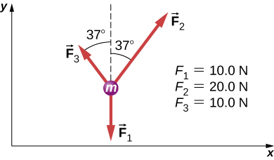

Solution



1. A body of mass 2.0 kg is moving along the *x*-axis with a speed of 3.0 m/s at the instant represented below. (a) What is the acceleration of the body? (b) What is the body’s velocity 10.0 s later? (c) What is its displacement after 10.0 s?

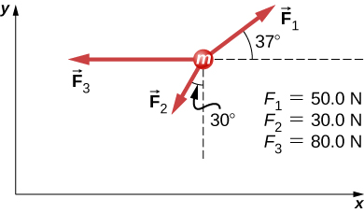

Solution

a. ; b. , so the magnitude of  is ; We find the velocity using a kinematic equation:

. c. We use another kinematic equation:



1. Force  has twice the magnitude of force . Find the direction in which the particle accelerates in this figure.

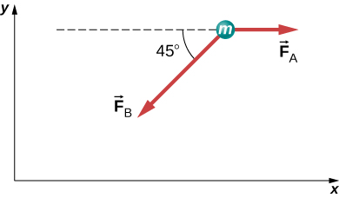

Solution



(We add , because the angle is in quadrant IV.)

1. Shown below is a body of mass 1.0 kg under the influence of the forces , , and . If the body accelerates to the left at what are  and ?

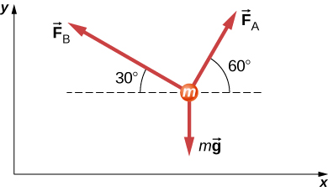

Solution

 and 

1. A force acts on a car of mass *m* so that the speed *v* of the car increases with position *x* as , where *k* is constant and all quantities are in SI units. Find the force acting on the car as a function of position.

Solution

 First, take the derivative of the velocity function to obtain Then apply Newton’s second law

1. A 7.0-N force parallel to an incline is applied to a 1.0-kg crate. The ramp is tilted at  and is frictionless. (a) What is the acceleration of the crate? (b) If all other conditions are the same but the ramp has a friction force of 1.9 N, what is the acceleration?

Solution

a. ; b. 

1. Two boxes, A and B, are at rest. Box A is on level ground, while box B rests on an inclined plane tilted at angle  with the horizontal. (a) Write expressions for the normal force acting on each block. (b) Compare the two forces; that is, tell which one is larger or whether they are equal in magnitude. (c) If the angle of incline is , which force is greater?

Solution

a. For box A,  and ; b.  because for , ; c.  when 

1. A mass of 250.0 g is suspended from a spring hanging vertically. The spring stretches 6.00 cm. How much will the spring stretch if the suspended mass is 530.0 g?

Solution

*k* = 40.8 N/m, so the stretch will be 12.7 cm

1. As shown below, two identical springs, each with the spring constant 20 N/m, support a 15.0-N weight. (a) What is the tension in spring A? (b) What is the amount of stretch of spring A from the rest position?

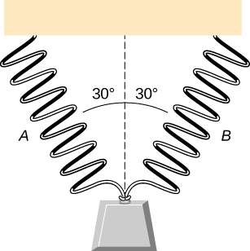

Solution

a. 8.66 N; b. 0.433 m

1. Shown below is a 30.0-kg block resting on a frictionless ramp inclined at  to the horizontal. The block is held by a spring that is stretched 5.0 cm. What is the force constant of the spring?

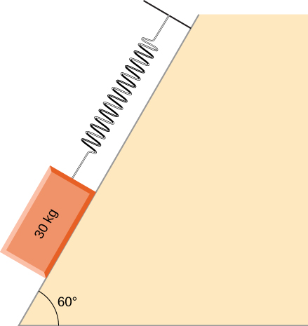

Solution

5100 N/m

1. In building a house, carpenters use nails from a large box. The box is suspended from a spring twice during the day to measure the usage of nails. At the beginning of the day, the spring stretches 50 cm. At the end of the day, the spring stretches 30 cm. What fraction or percentage of the nails have been used?

Solution

0.40 or 40%

1. A force is applied to a block to move it up a  incline. The incline is frictionless. If  and , what is the magnitude of the acceleration of the block?

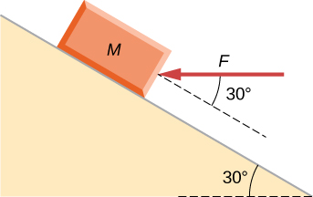

Solution



1. Two forces are applied to a 5.0-kg object, and it accelerates at a rate of  in the positive *y*-direction. If one of the forces acts in the positive *x*-direction with magnitude 12.0 N, find the magnitude of the other force.

Solution

16 N

1. The block on the right shown below has more mass than the block on the left (). Draw free-body diagrams for each block.

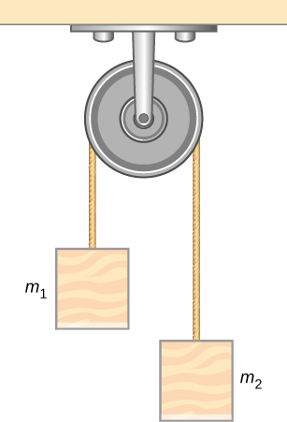

Solution

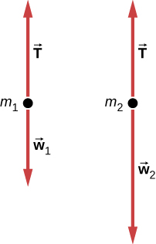

**Challenge Problems**

1. If two tugboats pull on a disabled vessel, as shown here in an overhead view, the disabled vessel will be pulled along the direction indicated by the result of the exerted forces. (a) Draw a free-body diagram for the vessel. Assume no friction or drag forces affect the vessel. (b) Did you include all forces in the overhead view in your free-body diagram? Why or why not?

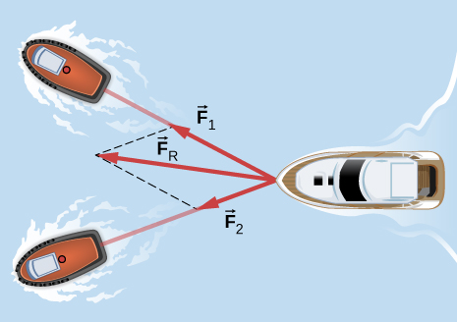

Solution

a.

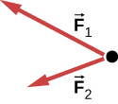;

b. No;  is not shown, because it would replace  and . (If we want to show it, we could draw it and then place squiggly lines on  and  to show that they are no longer considered.)

1. A 10.0-kg object is initially moving east at 15.0 m/s. Then a force acts on it for 2.00 s, after which it moves northwest, also at 15.0 m/s. What are the magnitude and direction of the average force that acted on the object over the 2.00-s interval?

Solution

138.64 N at  north of west

1. On June 25, 1983, shot-putter Udo Beyer of East Germany threw the 7.26-kg shot 22.22 m, which at that time was a world record. (a) If the shot was released at a height of 2.20 m with a projection angle of , what was its initial velocity? (b) If while in Beyer’s hand the shot was accelerated uniformly over a distance of 1.20 m, what was the net force on it?

Solution

a. 14.1 m/s; b. 601 N

1. A body of mass *m* moves in a horizontal direction such that at time *t* its position is given by  where *a*, *b*, and *c* are constants. (a) What is the acceleration of the body? (b) What is the time-dependent force acting on the body?

Solution

a. The acceleration can be found by taking the second derivative of position:

;

b. To find the force, we must apply Newton’s second law. We have the mass given as *m*. We found the acceleration as a function of time in (a):



1. A body of mass *m* has initial velocity  in the positive *x*-direction. It is acted on by a constant force *F* for time *t* until the velocity becomes zero; the force continues to act on the body until its velocity becomes  in the same amount of time. Write an expression for the total distance the body travels in terms of the variables indicated.

Solution



1. The velocities of a 3.0-kg object at  and  are  and , respectively. If the object is moving at constant acceleration, what is the force acting on it?

Solution



1. A 120-kg astronaut is riding in a rocket sled that is sliding along an inclined plane. The sled has a horizontal component of acceleration of  and a downward component of . Calculate the magnitude of the force on the rider by the sled. (*Hint*: Remember that gravitational acceleration must be considered.)

Solution

936 N

1. Two forces are acting on a 5.0-kg object that moves with acceleration  in the positive *y*-direction. If one of the forces acts in the positive *x*-direction and has magnitude of 12 N, what is the magnitude of the other force?

Solution

16 N

1. Suppose that you are viewing a soccer game from a helicopter above the playing field. Two soccer players simultaneously kick a stationary soccer ball on the flat field; the soccer ball has mass 0.420 kg. The first player kicks with force 162 N at  north of west. At the same instant, the second player kicks with force 215 N at  east of south. Find the acceleration of the ball in  and  form.

Solution



1. A 10.0-kg mass hangs from a spring that has the spring constant 535 N/m. Find the position of the end of the spring away from its rest position. (Use .)

Solution

−0.183 m

1. A 0.0502-kg pair of fuzzy dice is attached to the rearview mirror of a car by a short string. The car accelerates at constant rate, and the dice hang at an angle of  from the vertical because of the car’s acceleration. What is the magnitude of the acceleration of the car?

Solution



1. At a circus, a donkey pulls on a sled carrying a small clown with a force given by . A horse pulls on the same sled, aiding the hapless donkey, with a force of . The mass of the sled is 575 kg. Using  and  form for the answer to each problem, find (a) the net force on the sled when the two animals act together, (b) the acceleration of the sled, and (c) the velocity after 6.50 s.

Solution

a. ; b. ; c. 

1. Hanging from the ceiling over a baby bed, well out of baby’s reach, is a string with plastic shapes, as shown here. The string is taut (there is no slack), as shown by the straight segments. Each plastic shape has the same mass *m*, and they are equally spaced by a distance *d*, as shown. The angles labeled  describe the angle formed by the end of the string and the ceiling at each end. The center length of sting is horizontal. The remaining two segments each form an angle with the horizontal, labeled . Let  be the tension in the leftmost section of the string,  be the tension in the section adjacent to it, and  be the tension in the horizontal segment. (a) Find an equation for the tension in each section of the string in terms of the variables *m*, *g*, and . (b) Find the angle  in terms of the angle . (c) If , what is the value of ? (d) Find the distance *x* between the endpoints in terms of *d* and .

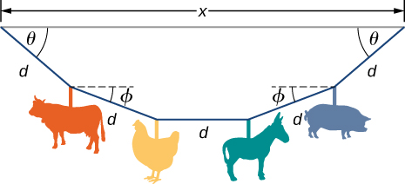

Solution

a.  , ,  b. ; c. ; (d) 

1. A bullet shot from a rifle has mass of 10.0 g and travels to the right at 350 m/s. It strikes a target, a large bag of sand, penetrating it a distance of 34.0 cm. Find the magnitude and direction of the retarding force that slows and stops the bullet.

Solution



1. An object is acted on by three simultaneous forces: , , and . The object experiences acceleration of . (a) Find the acceleration vector in terms of *m*. (b) Find the mass of the object. (c) If the object begins from rest, find its speed after 5.00 s. (d) Find the components of the velocity of the object after 5.00 s.

Solution

a.  b. 1.38 kg; c. 21.2 m/s; d. 

1. In a particle accelerator, a proton has mass  and an initial speed of . It moves in a straight line, and its speed increases to  in a distance of 10.0 cm. Assume that the acceleration is constant. Find the magnitude of the force exerted on the proton.

Solution



1. A drone is being directed across a frictionless ice-covered lake. The mass of the drone is 1.50 kg, and its velocity is . After 10.0 s, the velocity is . If a constant force in the horizontal direction is causing this change in motion, find (a) the components of the force and (b) the magnitude of the force.

Solution

a. ; b. 1.08 N

This file is copyright 2016, Rice University. All Rights Reserved.